Setting Up Notifications throughout TME
Users can receive notifications by text or email messaging for various functions throughout TME--creation of work orders, Asset going into downtime state, below minimum reached on an Inventory Item, etc.
The messages and subject lines of these Notifications are set up in this Notifications submodule in Settings. Setting up the Notifications to be sent to specific email or text addresses is done within the User's individual profiles.
A) Setting up the Notification
The Notifications Viewer lists the notifications set up for the various triggers in TME. It can be accessed via Go To from the Task Bar (Go To > Settings > System Settings > Notifications) or from the Notifications Sub-Module within the Settings Menu Group. The data can be searched and sorted in order to easily access a specific record.
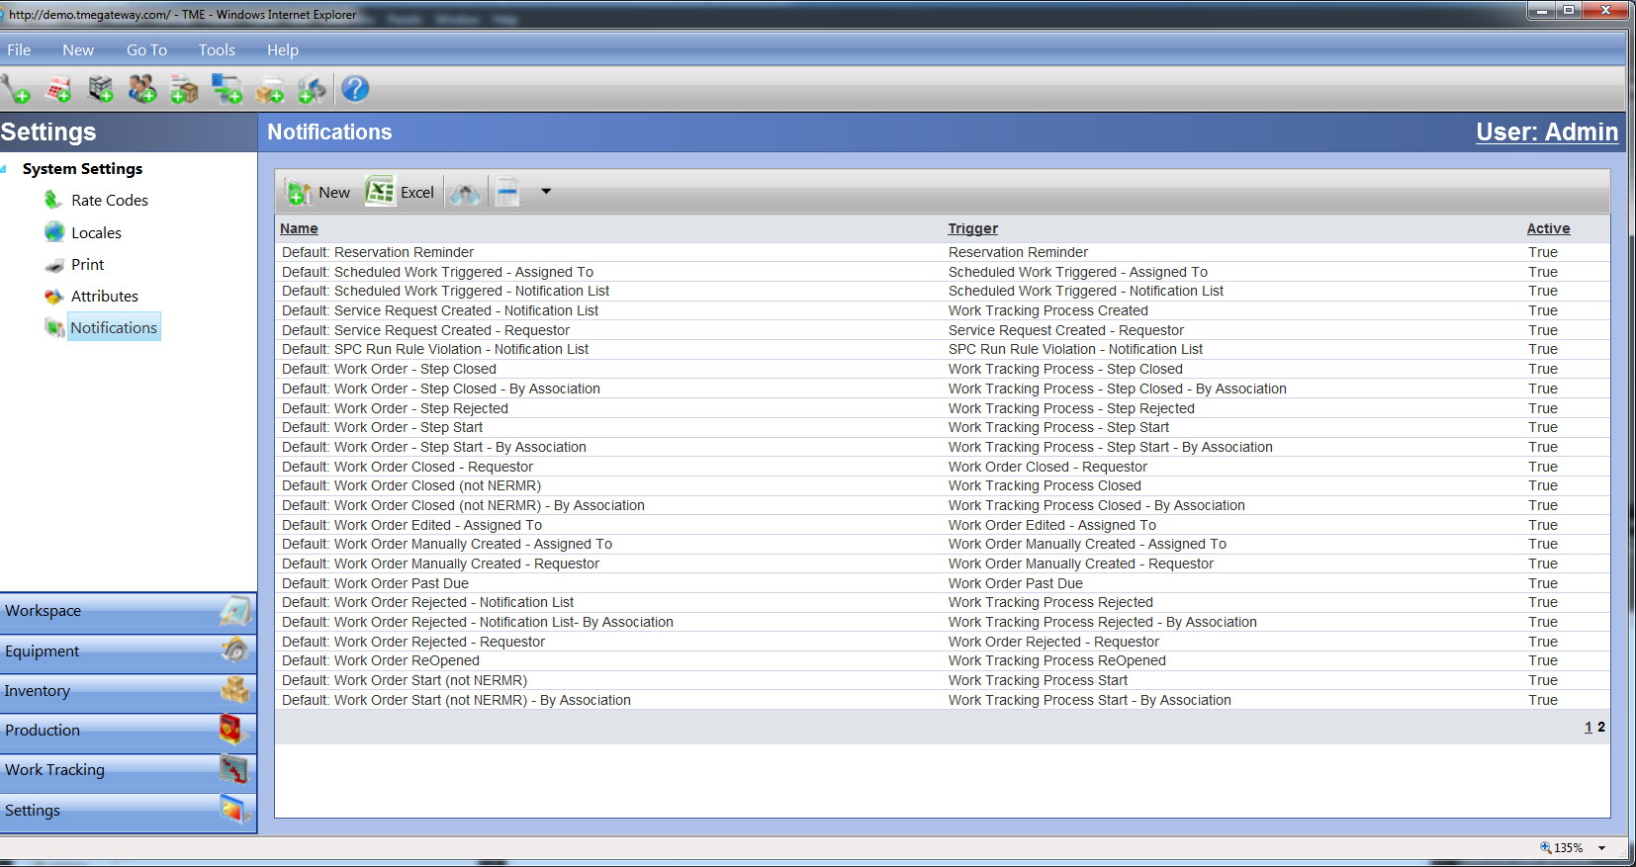
Figure 1 Notifications List
New Notifications can be added by clicking on the 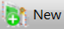 icon at the left side of the Viewer Toolbar. A blank Details popup screen will appear and will be set as a default to the General tab of the Information link.
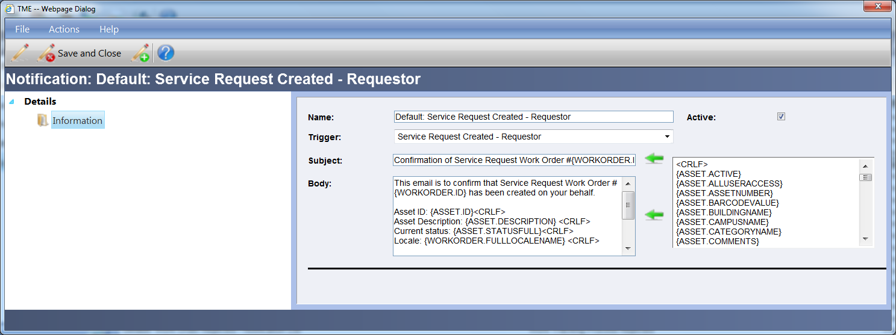
Figure 2 Notification Detail Screen
Type in the Name of the Notification which will appear in the drop-down list for selection; select the Trigger for which the Notification is to be sent out, select the Active checkbox and type the Subject into the Subject text field and the Message into the Body text field.
To insert variables into the Subject line, select the variable from the list provided and click the top Copy selected item to text box icon to move that value into the Subject line. The value will be placed at the end of the Subject line and can be cut (Ctrl C on the keyboard) and pasted (Ctrl V on the keyboard) into another position within the Subject.
To insert variables into the body of the message, select the variable from the list provided and click the bottom Copy selected item to text box icon to move that value into the body. The value will be placed at the end of the message and can be cut (Ctrl C on the keyboard) and pasted (Ctrl V on the keyboard) into another position within the message.
To include a carriage return at the end of a line, insert the <CRLF> variable located at the top of the variable list and place it at the end of the line. This value can be copied and pasted throughout the message as necessary.
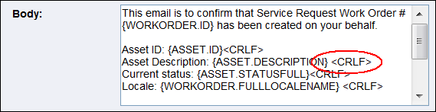
Figure 3 Setup of Carriage Return in Notification Message
Save using the Detail Toolbar or Taskbar. To close the record without saving, click on File on the Detail Taskbar and then Close or click on the X at the top right corner of the Details Screen window.
To edit a Notification, select a record within the Notification Viewer and double click anywhere within the row or right click within the row and select "View." The Notification Details screen appears set to the Information Link. Make any edits as necessary on the General tab and save using the Detail Toolbar or Taskbar.
To delete, double click anywhere within the row of the specific Notification and delete the record via Actions on the Details Taskbar or right click on that row and select "Delete."
B) Setting up the Notifications for Work Tracking
- Specific Users can receive email/text notifications for the following events as soon as they occur regardless of the Asset or Requestor: Non-Equipment Related Maintenance Request Created - Notification List, Repair Request Created-Notification List, Work Order Closed-Notification List, Work Order Edited-Notification List, Work Order Manually Created-Notification List, and Work Order Rejected-Notification List. Notifications for Work Tracking is accessed via Work Tracking > Processes. Open up the record for the Process, click on Revisions. Open up the record for the Revision in Question and click on Notification.
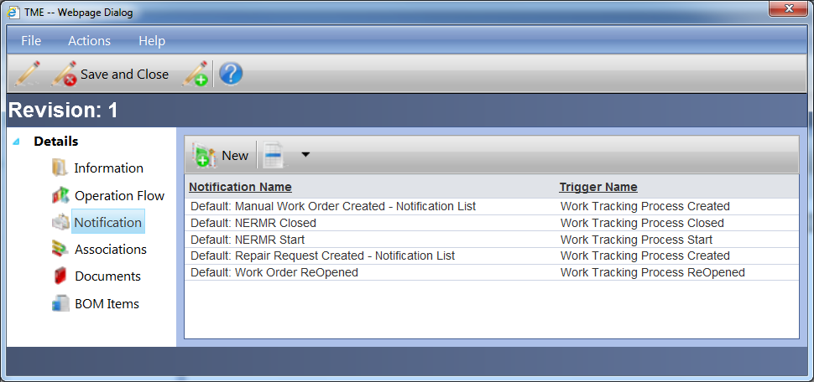
Figure 4 Process Revision Notification Viewer
- There are Notifications that can be set up for Processes whereby the Work Orders are associated with specified Assets: Work Tracking Process –Closed – By Association, - Start – By Association, - Rejected – By Association. To set up, Open up the record for the Process, click on Revisions. Open up the record for the Revision in Question and click on Associations.
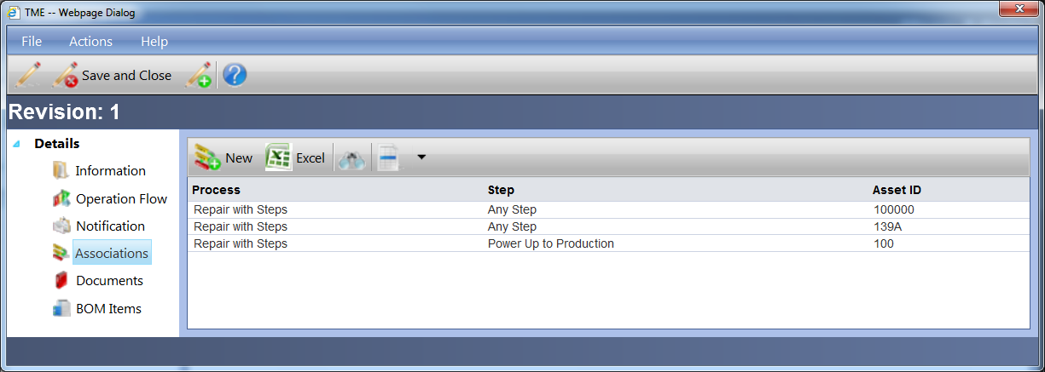
Figure 5 Process Revision Associations Viewer
Click on 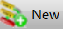 and select the Step (or leave as Any Step) for which the Association is to be made. Select the Asset, click Save. Click on Notifications.
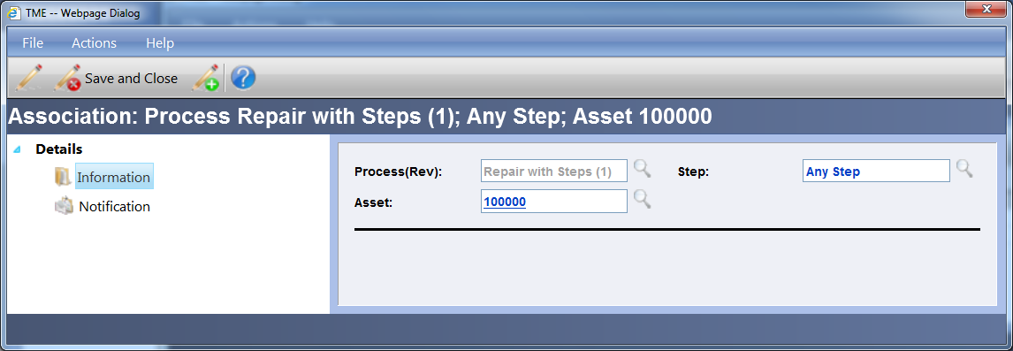
Figure 6 Association Detail Screen
- Users can also be set up to receive notifications for the following events set for individual Steps within a Work Order: Work Tracking Process – Step Closed, - Step Rejected, - Step Start. This is accessed via Operations > Revisions. Open up the record for the Revision in Question, click on Steps and open up the appropriate Step. Click on Notifications.
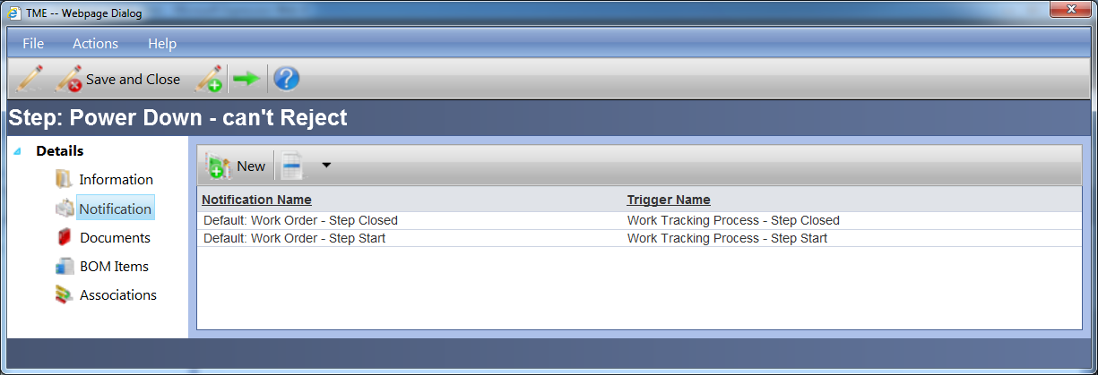
Figure 7 Step Notification Viewer
- In addition, User can receive notifications for Steps that only are associated with specified Assets: Work Tracking Process – Step Closed – By Association, - Step Start – By Association. This is set up via via Operations > Revisions. Open up the record for the Revision in Question, click on Steps and open up the appropriate Step. Click on Associations.
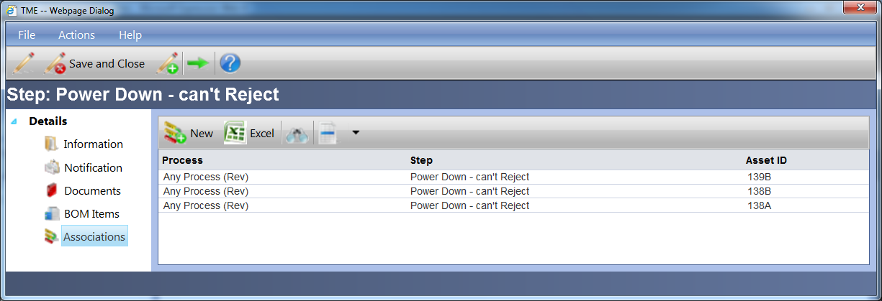
Figure 8 Step Associations Viewer
Click on and select the Step for which the Association is to be made. Select the Asset, click Save. Click on Notifications.
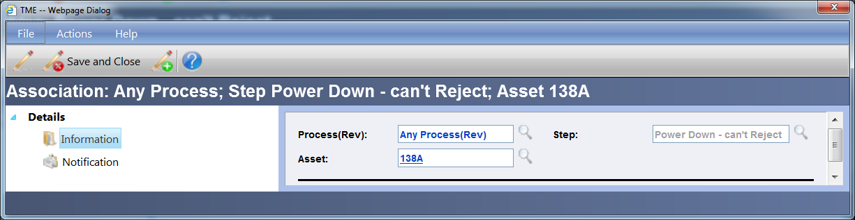
Figure 9 Step Association Detail Screen
- Last, but not least, the same Associations can be set up on the Asset Detail screen. Click on Process Associations and follow the same process as above.
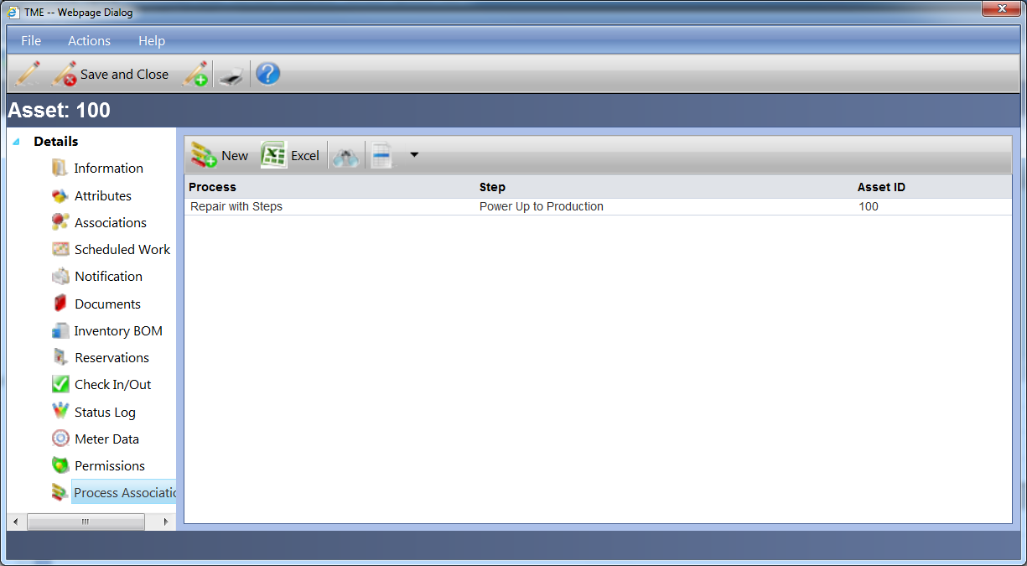
Figure 10 Asset Process Associations
For all five setups, the Notifications can be added to any of the lists by clicking on the icon. The Trigger Association screen will appear. Select the appropriate Trigger from the drop down list and the Notification. The Administrator can set up multiple Notifications (with different subject lines, messages, etc.) for each Trigger.
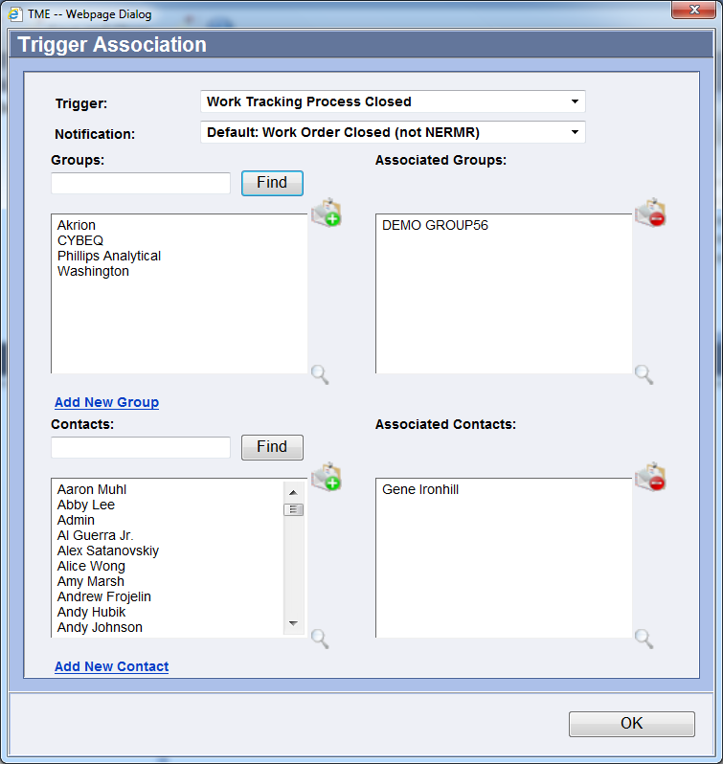
Figure 11 Trigger Association Screen
Select the Groups to receive the Notification (hold the Ctrl key if making multiple selections) from the Groups field and click on the 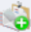 icon to the right of the field. The groups selected are now visible in the Associated Groups field. To remove a group from the Associated Group(s), select the Group (hold the Ctrl key if making multiple selections) from the Associated Groups field and click on the 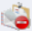icon to the right of the field.
The same process applies for selecting individual Contacts.
To search for a Group or Contact, type in the starting letters within the text field above the listed Groups/Contacts. Click Find and the list will filter accordingly. To return to the full list, remove the typed entry and click Find again.
Continue setting up each Trigger and Notification needed and then click OK to submit.
NOTE: a Group or Contact may be set up to receive multiple notifications for the same Trigger. For example, a Notification may be setup for Repair Request Created with a long message that's suitable for email while another Notification may be set up for the same trigger that is brief and suitable for texting. The designation of where to send each Notification (email or text address) is set up at the User's profile. See the Contacts portion of the Contacts section of Online Help for assistance on setting up the User profile.
To Add a New Group or Contact from within this screen, click on the corresponding links located under the Group and Contacts fields. See the Contacts and Groups portions of the Contacts section of Online Help for assistance on setting up the Group/Contact.
C) Setting up the Notifications for Individual Records for Assets, Inventory, Scheduled Work, WIP Work Orders and Data Collection/SPC Run Rule Violations
I. Assets: Specific Users can receive email/text notifications for the following events for Assets as soon as they occur: Asset Downtime - Initial Event, Asset Downtime Event (all events, not just the initial), Repair Request Created, Service Request Created, Reservation Request, and Return to Uptime . To set up, click on the Notification link on the Asset's Detail Screen (Asset Management > Assets) and follow the same process as with setting up Notifications for Work Tracking as defined above.
II. Inventory: Specific Users can receive email/text notifications for the following events for Inventory Items as soon as they occur: Inventory Above Maximum - Overall and Inventory Below Minimum - Overall. These notifications will alert Users regarding the overall on-hand quantity of the Item within the entire system (minimum and maximum values defined on the Information screen). To set up, click on the Notification link on the Item's Detail Screen (Inventory > Items).
III. Inventory Locales: Specific Users can also receive email/text notifications for Below Minimum and Above Maximum for designated Locales for individual Inventory Items. To set up, click on the Notification link on the Item Location's Detail Screen (Inventory > Items > Location Mgt).
IV. Scheduled Work: Specific Users can receive email/text notifications for the following events as soon as they occur: Scheduled Work Triggered - Assigned To and Scheduled Work Triggered - Notification List. To set up, click on the Notification link on the Scheduled Work's Detail Screen (Work Tracking > Scheduled Work).
V. WIP: Specific Users can receive email/text notifications for the following events as soon as they occur: WIP Work Order Closed, WIP Work Order Closed-Assigned To, WIP Work Order Created, WIP Work Order Created-Assigned To, WIP Work Order Future Hold, WIP Work Order Hold, WIP Work Order Rejected, WIP Work Order Rejected-Assigned To, WIP Work Order Released, WIP Work Order Released-Assigned To, WIP Work Order Scrapped, WIP Work Order Step Complete, WIP Work Order Step Resume, WIP Work Order Step Started, WIP Work Order Step Suspended, and WIP Work Order To Inventory. To set up the WIP Work Order notifications, click on the Notification link on the Process Revision’s Detail Screen (WIP > Processes > Revisions). To set up the WIP Work Order Step notifications, click on the Notification link on the Operation Step’s Detail Screen (WIP > Operations > Revisions > Steps).
VI. Attributes/Data Collection/SPC: Specific Users can receive email/text notifications the violation of Attributes/Data Collection/SPC run rules. There are separate notifications for run rule violations for different objects: Asset Run Rule Violation, Inventory Item Run Rule Violation, Inventory Item Batch Run Rule Violation, Inventory Item Serial Number Run Rule Violation, Inventory Transaction Run Rule Violation Locale Run Rule Violation, Production Log Run Rule Violation, Purchase Order Run Rule Violation, Receipt Item Run Rule Violation, Receipt Run Rule Violation, Requisition Run Rule Violation, WIP Data Collect Run Rule Violation, Work Order Run Rule Violation and Work Order Step Run Rule Violation.
To set up, click on the Notification link on the Attribute or Collection Setup Detail Screen for the individual object such as an Asset, Inventory Item, Work Tracking Process (for example, Asset > Collection Setup).
To set up for WIP Work Order Collection, click on the Notification link via WIP > Operations > Revisions > Steps > Data Collection > Details link (becomes available upon selecting a Data Collection and saving the screen).
To set up for WIP Operations and Processes, click on the Notification link via Tools > Options > WIP > Operation or Process Attributes > Group Item.

To set up for All Assets, click on the Notification link via Tools > Options > Assets > Attributes/Collections (All Assets) > Group Item.
To set up for Purchase Orders and Requisitions, click on the Notification link via Tools > Options > Purchasing > PO or Req Attributes > Group Item.
To set up for Production, click on the Notification link via Tools > Options > Production > Attributes > Group Item.
To set up for Locales, click on the Notification link via Tools > Options > System > Locale Attributes > Group Item.
To set up for Contact Groups and Contact Group Members, click on the Notification link via Tools > Options > Contacts > Contact Groups or Contract Group Member Attributes > Group Item.
To set up for Inventory Transactions, All Item Batches, All Item Serial Numbers, Receipts and Receipt Items, click on the Notification link via Tools > Options > Inventory > [XXX] Attributes/Collections > Group Item.
To set up based on Category or Subcategory for Assets or Inventory Items, click on click on the Notification link via Tools > Options > Assets or Inventory > Categories/SubCategories> Drill to the Category or SubCategory > Group Item.
To set up for Work Tracking Work Orders, click on the Notification link via Tools > Options > Work Tracking > Attributes > Group Item.
D) Setting up Notifications to Be Sent to Alternate Email/Text Addresses
Select the User's record within the Contacts Viewer and double click anywhere within the row or right click within the row and select "View." The Contacts Details screen appears set to the Information Link. Click on the Notification Rule link.
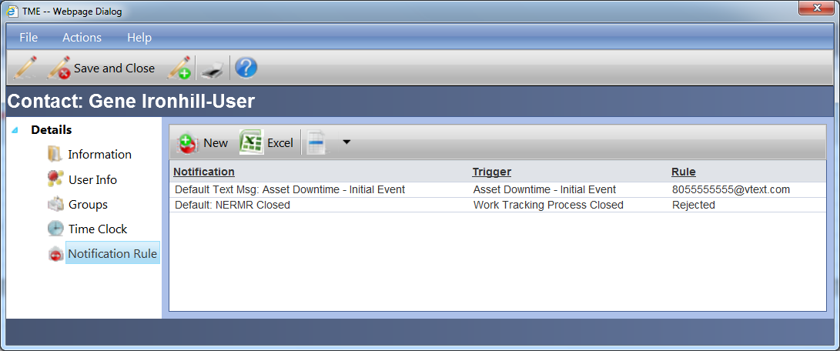
Figure 12 Contact Notification Rule Viewer
The Notification Rules help the system determine which email address to send any particular Notification to for a User with multiple addresses. For example, a Downtime Event trigger can be set up with multiple notifications--one with lots of information to be sent to an email address and one with very limited information to be sent to a text address.
To add a new record, click on the 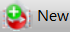 icon. A Details popup screen will appear and will as a default be set to the General tab of the Information link.
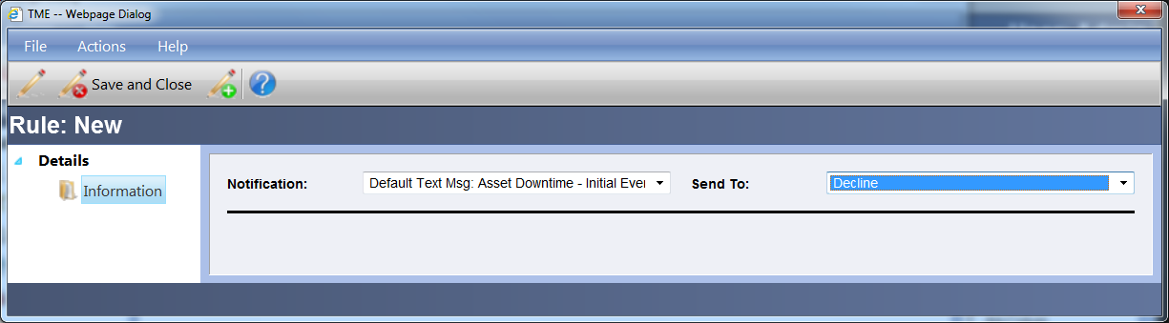
Figure 13 Contact Notification Rule Detail Screen
Select the Notification from the drop down list and the email address from the Send To drop down list. In lieu of an email address, "Decline" can be selected and if that particular notification is to be sent out, the User will not receive it. Save using the Detail Toolbar or Taskbar, close by clicking on File on the Detail Taskbar and then Close or click on the X at the top right corner of the Details Screen window.

